ASSIGNMENT (13.06.24)

1.Height of Binary Tree After Subtree Removal Queries

class TreeNode:

def __init__(self, val=0, left=None, right=None):

self.val = val

self.left = left

self.right = right

def height_of_tree(node):

if not node:

return -1

left_height = height_of_tree(node.left)

right_height = height_of_tree(node.right)

return 1 + max(left_height, right_height)

def build_tree_from_list(vals):

if not vals:

return None

nodes = [None if val is None else TreeNode(val) for val in vals]

kid_idx = 1

for idx, node in enumerate(nodes):

if node is not None:

if kid_idx < len(nodes) and nodes[kid_idx] is not None:

node.left = nodes[kid_idx]

kid_idx += 1

if kid_idx < len(nodes) and nodes[kid_idx] is not None:

node.right = nodes[kid_idx]

kid_idx += 1

return nodes[0]

def find_node(root, val):

if root is None:

return None

if root.val == val:

return root

left_result = find_node(root.left, val)

if left_result is not None:

return left_result

return find_node(root.right, val)

def height_after_removal(root, query):

target_node = find_node(root, query)

if not target_node:

return height_of_tree(root)

if target_node.left:

original_left = target_node.left

target_node.left = None

height_with_left_removed = height_of_tree(root)

target_node.left = original_left

return height_with_left_removed

if target_node.right:

original_right = target_node.right

target_node.right = None

height_with_right_removed = height_of_tree(root)

target_node.right = original_right

return height_with_right_removed

return height_of_tree(root)

def height_after_subtree_removal(root, queries):

root_tree_height = height_of_tree(root)

results = []

for query in queries:

results.append(height_after_removal(root, query))

return results

root_vals = [1, 3, 4, 2, None, 6, 5, None, None, None, None, None, 7]

queries = [4]

root = build_tree_from_list(root_vals)

print(height_after_subtree_removal(root, queries))

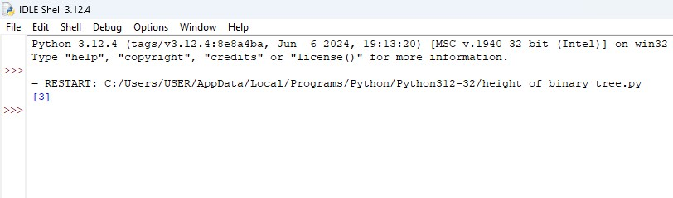

2. Sort Array by Moving Items to Empty Space

def min_operations_to_sort(nums):

n = len(nums)

visited = [False] * n

zero_index = nums.index(0)

swaps = 0

for i in range(n):

if not visited[i] and nums[i] != i:

cycle_length = 0

x = i

while not visited[x]:

visited[x] = True

x = nums[x]

cycle_length += 1

if cycle_length > 0:

swaps += cycle_length - 1

if zero_index == 0 or zero_index == n - 1:

return swaps

else:

return swaps + 1

nums = [4, 2, 0, 3, 1]

print(min_operations_to_sort(nums))

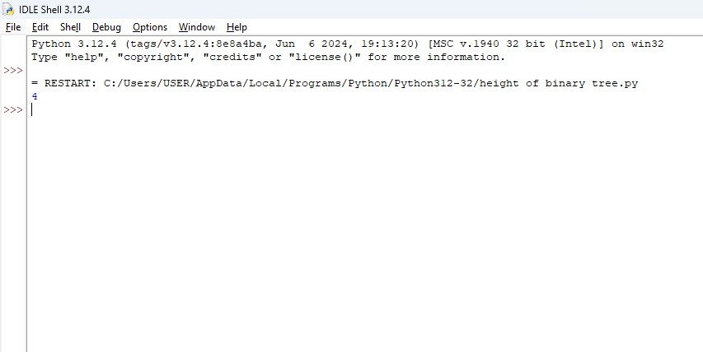

3. Apply Operations to an Array

def apply_operations(nums):

n = len(nums)

for i in range(n - 1):

if nums[i] == nums[i + 1]:

nums[i] *= 2

nums[i + 1] = 0

result = []

zero_count = 0

for num in nums:

if num != 0:

result.append(num)

else:

zero_count += 1

result.extend([0] * zero_count)

return result

nums = [1, 2, 2, 1, 1, 0]

print(apply_operations(nums))

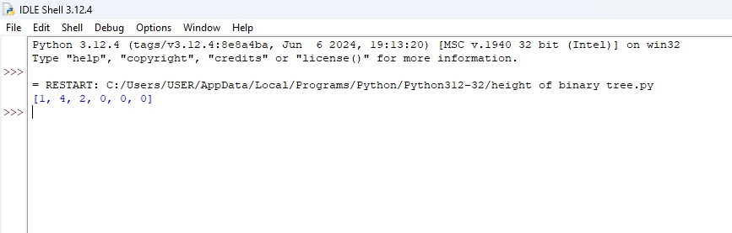

4. Maximum Sum of Distinct Subarrays With Length K

def max_sum_of_distinct_subarrays(nums, k):

if len(nums) < k:

return 0

n = len(nums)

max_sum = 0

current_sum = 0

window_start = 0

element_set = set()

for window_end in range(n):

while nums[window_end] in element_set:

element_set.remove(nums[window_start])

current_sum -= nums[window_start]

window_start += 1

element_set.add(nums[window_end])

current_sum += nums[window_end]

if window_end - window_start + 1 == k:

max_sum = max(max_sum, current_sum)

element_set.remove(nums[window_start])

current_sum -= nums[window_start]

window_start += 1

return max_sum

nums1 = [1, 5, 4, 2, 9, 9, 9]

k1 = 3

print(max_sum_of_distinct_subarrays(nums1, k1))

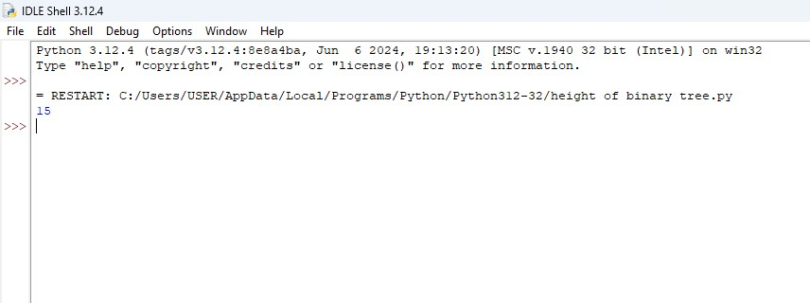

5. Total Cost to Hire K Workers

from heapq import heappop, heappush

def total_cost_to_hire_workers(costs, k, candidates):

n = len(costs)

left_heap = []

right_heap = []

for i in range(min(candidates, n)):

heappush(left_heap, (costs[i], i))

for i in range(max(candidates, n - candidates), n):

heappush(right_heap, (costs[i], i))

total_cost = 0

hired_count = 0

left_index = min(candidates, n)

right_index = max(candidates, n - candidates)

while hired_count < k:

if left_heap and (not right_heap or left_heap[0][0] <= right_heap[0][0]):

cost, index = heappop(left_heap)

total_cost += cost

if left_index < right_index:

heappush(left_heap, (costs[left_index], left_index))

left_index += 1

else:

cost, index = heappop(right_heap)

total_cost += cost

if right_index > left_index:

heappush(right_heap, (costs[right_index - 1], right_index - 1))

right_index -= 1

hired_count += 1

return total_cost

costs = [17, 12, 10, 2, 7, 2, 11, 20, 8]

k = 3

candidates = 4

print(total_cost_to_hire_workers(costs, k, candidates))

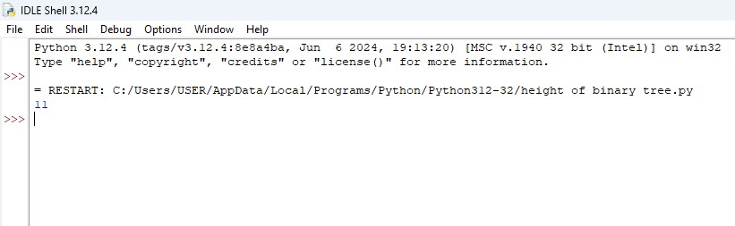

6. Minimum Total Distance Traveled

def min_total_distance_traveled(robots, factories):

robots.sort()

factories.sort()

r_len = len(robots)

f_len = len(factories)

dp = [[float('inf')] * (f_len + 1) for _ in range(r_len + 1)]

dp[0][0] = 0

for i in range(r_len + 1):

dp[i][0] = 0

for j in range(1, f_len + 1):

dp[0][j] = 0

for i in range(1, r_len + 1):

for j in range(1, f_len + 1):

dp[i][j] = dp[i][j-1]

limit_j = factories[j-1][1]

total_distance = 0

for t in range(1, min(limit_j, i) + 1):

total_distance += abs(robots[i-t] - factories[j-1][0])

dp[i][j] = min(dp[i][j], dp[i-t][j-1] + total_distance)

return dp[r_len][f_len]

robots = [0, 4, 6]

factories = [[2, 2], [6, 2]]

print(min_total_distance_traveled(robots, factories))

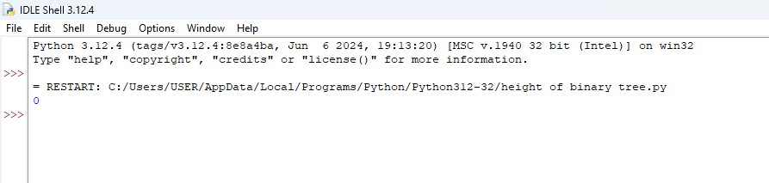

7. Minimum Subarrays in a Valid Split

from math import gcd

from functools import lru_cache

def min_subarrays_in_valid_split(nums):

n = len(nums)

dp = [float('inf')] * (n + 1)

dp[0] = 0

@lru_cache(None)

def gcd_range(l, r):

result = nums[l]

for i in range(l + 1, r):

result = gcd(result, nums[i])

if result == 1:

return 1

return result

for j in range(1, n + 1):

for i in range(j):

if gcd(nums[i], nums[j - 1]) > 1:

dp[j] = min(dp[j], dp[i] + 1)

return dp[n] if dp[n] != float('inf') else -1

nums1 = [2, 6, 3, 4, 3]

print(min_subarrays_in_valid_split(nums1))

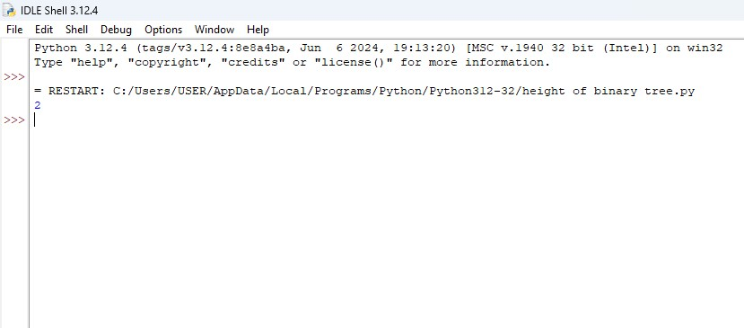

8. Number of Distinct Averages

def distinct_averages(nums):

nums.sort()

averages = set()

i, j = 0, len(nums) - 1

while i < j:

avg = (nums[i] + nums[j]) / 2

averages.add(avg)

i += 1

j -= 1

return len(averages)

nums1 = [4, 1, 4, 0, 3, 5]

print(distinct_averages(nums1))

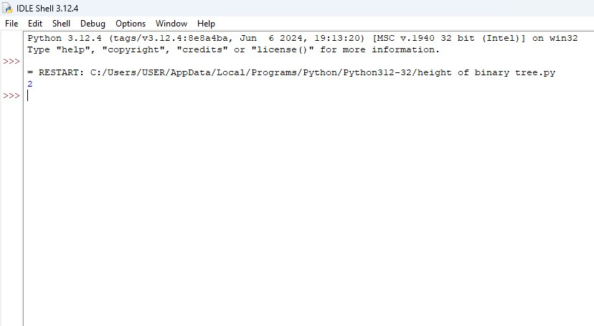

9. Count Ways To Build Good Strings

def count_good_strings(low, high, zero, one):

MOD = 10**9 + 7

dp = [0] * (high + 1)

dp[0] = 1

for i in range(1, high + 1):

if i >= zero:

dp[i] += dp[i - zero]

if i >= one:

dp[i] += dp[i - one]

dp[i] %= MOD

result = sum(dp[low:high + 1]) % MOD

return result

low1, high1, zero1, one1 = 3, 3, 1, 1

print(count_good_strings(low1, high1, zero1, one1))

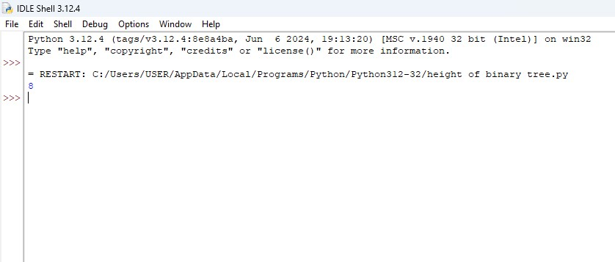

10. Most Profitable Path in a Tree

def most_profitable_path(edges, bob, amount):

from collections import defaultdict, deque

tree = defaultdict(list)

for u, v in edges:

tree[u].append(v)

tree[v].append(u)

def find_bob_path(node, parent):

if node == 0:

return [node]

for neighbor in tree[node]:

if neighbor != parent:

path = find_bob_path(neighbor, node)

if path:

return path + [node]

return []

bob_path = find_bob_path(bob, -1)

bob_time = {node: time for time, node in enumerate(bob_path)}

def dfs(node, parent, time):

profit = amount[node]

if node in bob_time:

if bob_time[node] < time:

profit = 0

elif bob_time[node] == time:

profit //= 2

max_profit = float('-inf')

is_leaf = True

for neighbor in tree[node]:

if neighbor != parent:

is_leaf = False

max_profit = max(max_profit, dfs(neighbor, node, time + 1))

if is_leaf:

return profit

return profit + max_profit

return dfs(0, -1, 0)

edges1 = [[0, 1], [1, 2], [1, 3], [3, 4]]

bob1 = 3

amount1 = [-2, 4, 2, -4, 6]

print(most_profitable_path(edges1, bob1, amount1))

